|  |  |  |
| --- | --- | --- |
| **Students Details** | HNDSE 24.2 F |  |
| **Module Name:** | Robotics Application Development |
| **Module Lecturer/Course Coordinator:** | Mr. R G V Pathirana |
| **Department:** | School of Computing | |
| **Submission Due on:** | 09th of December 2024 | |
| **Type of Coursework:** | Group | |
| **Title of the Coursework:** | Implementing an Automated Robot (01st Progression) | |

***Student Details:***

|  |  |  |
| --- | --- | --- |
|  | **Student No.** | **Student Name** |
| **01** | COHNDSE242F- 042 | Azward M A |
| **02** | COHNDSE242F- 041 | Ilma M H F |
| **03** | COHNDSE242F- 063 | Iroshan S G H |

|  |
| --- |
| **Office use only :** |
| Date Stamp Required of the Department |

**NATIONAL INSTITUTE OF BUSINESS MANAGEMENT**

**HIGHER NATIONAL DIPLOMA IN SOFTWARE ENGINEERING**

**COURSEWORK**

**Robotics Application Development**

**Pet Robot (01st Progression)**

**SUBMITTED BY**

|  |  |
| --- | --- |
| COHNDSE242F- 042 | Azward M A |
| COHNDSE242F- 041 | Ilma M H F |
| COHNDSE242F- 063 | Iroshan S G H |
|  |  |

**Date of Submission:** 17th of January 2025

Contents

1. Problem Definition 4

2. Researching and Designing 5

2.1 Researching 5

2.2 Designing 7

3. Build the Robot (BOM) 8

4. Programming (Flow Chart) 10

5. Circuit Diagram (Simulation) 11

6. Evaluating the robot 17

6.1 Results of the operation 17

6.2 Limitation 17

6.3 Recommendation 18

7. Timeline 19

# Problem Definition

The proposed robotics application is a smart pet robot with following functions.

* Performs rotating, moving forwards and backward, tilting the head, wagging the tail
* Follows the user
* Emits sounds
* Avoids obstacles
* Neck belt which lights up corresponding to background darkness automatically

The above-mentioned functions are planned to control using commands given through a laptop. The purpose of implementing a pet robot is to replicate the traditional pet with an automated pet to provide the owner with companionship, entertainment and convenience with certain limitations. With the busy life cycle of the current population, their need is to minimize their workload and maintain their mental fitness. Therefore, the proposed pet robot will be suitable for the current generation as it reduces the maintenance cost and time for a traditional pet as it is automated, only needs a repair if any technical issues were met and it helps to enhance the mental well-being of an individual as well.

Basic requirements which are expected from the pet robot is to perform following activities.

* Perform functions mentioned in above
* Detecting obstacles and avoiding
* Identifying the background darkness

As per the above problem definition, the proposed pet robot will assist the user with its owned functions to replace a traditional pet with a robot instead.

# Researching and Designing

## Researching

According to the proposed robot, the focus of the implementation is given to its movements and functions performed. The following electronic components are needed to build the pet robot to function as expected.

1. Motors

* **Servo Motors** Facilitates implementing movement processes such as tilting the head, wagging the tail.
* DC Motors used to make the robot move front, backwards and rotate.

1. Sensors

* **Infrared sensors** are used to prevent the robot from hitting obstacles as it detects the object.
* **Ultrasonic sensor** is used to place the object away from the obstacle with a fixed distance because it can measure the amplitude between itself and the obstacle.
* **LDR sensor** which is on the neck belt of the pet which lights up in dark backgrounds automatically.

1. Arduino Board

* Considered as the brain of the robot as it is responsible for grabbing the inputs and controlling output using selected components.

1. Breadboard

* Used to connect components together in the circuit.

1. LED bulbs

* Used to light up the neck belt.

1. Lithium-Ion battery

* It is the power source for robots.

1. Motor Shield

* Used to control multiple servo motors in the robot

1. Buzzers

* This component is used to get audio output from the robot

1. Wires and Connectors

* Used to connect each component together.

1. DC Motor Controller

* Used to controller the speed and direction of the motor

1. Chassis

* The base structure which holds all the components of the robot.

1. Resistors

* Used to control the flow of electricity.

Apart from the above devices more tools and materials are needed to design the external appearance and fix the model as designed. Those will be mentioned in the fourth chapter.

## Designing

Following is a sketch of the pet robot to display where the certain components are added.

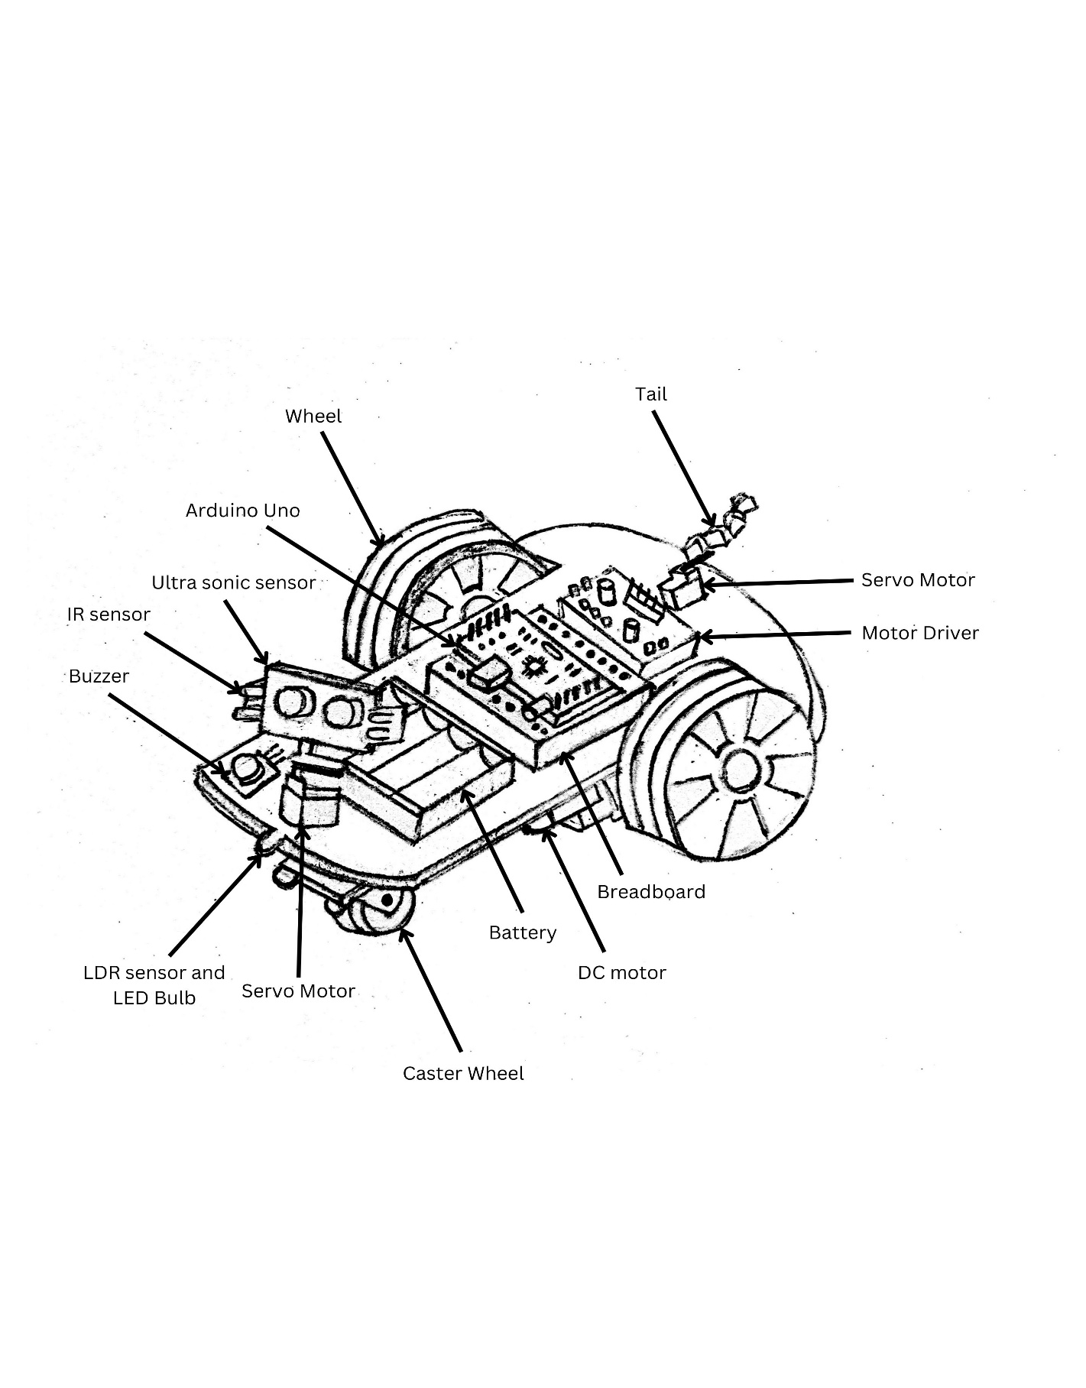

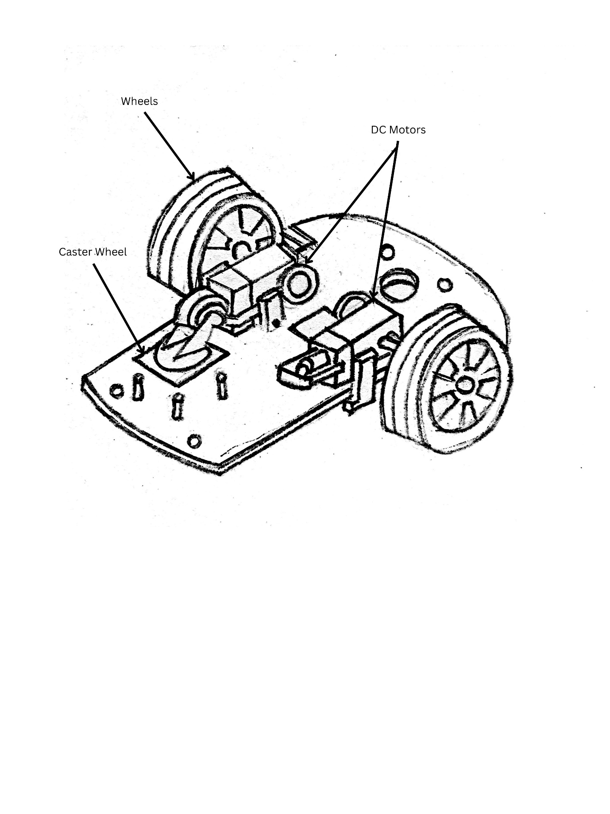

# Build the Robot (BOM)

To build the robot, the following tools, components and equipment are needed. They are listed as a bill of materials (BOM).

|  |  |  |  |
| --- | --- | --- | --- |
| **Component** | **Quantity** | **Amount (Rs)** | **Total(Rs)** |
| Chassis | 01 | 2500 | 2500 |
| Servo Motors | 02 | 390 | 780 |
| IR Sensor | 02 | 190 | 380 |
| LDR Sensor | 01 | 260 | 260 |
| Ultra Sonic Sensor | 01 | 250 | 250 |
| LED Bulbs | 01 pack | 80 | 80 |
| Arduino Uno | 01 | 2250 | 2250 |
| Jumper Cables (male to male) | 01 pack | 380 | 380 |
| Jumper Cables (female to female) | 01 pack | 270 | 270 |
| Jumper Cables (male to female) | 01 pack | 270 | 270 |
| Lithium-Ion battery (3500mah) | 690 | 08 | 5520 |
| DC Motor | 04 | 60 | 240 |
| Motor driver | 01 | 490 | 490 |
| Buzzers | 01 | 80 | 80 |
| Switch | 01 | 50 | 50 |
| Breadboard | 01 | 290 | 290 |
| Charging case | 01 | 240 | 240 |
| Glue Sticks | 06 | 40 | 240 |
| Glue Gun | 01 | 720 | 720 |
| Nuts | As requires | 100 | 100 |
| Soldering Iron | 01 | 790 | 790 |
| Soldering Wire | 01 role | 120 | 120 |
| Soldering Iron Stand | 01 | 490 | 490 |
| Scissor | 01 | 150 | 150 |
| Glue (normal) | 01 | 115 | 115 |
| Bristol Board | 01 | 55 | 55 |
| Super Glue | 01 | 95 | 95 |
| Paper Cutter | 01 | 200 | 200 |
| Double Tape | 01 | 750 | 750 |
| Plier | 01 | 1470 | 1470 |
| Resistors | 01 pack | 50 | 50 |
| Other |  | 200 | 200 |

|  |  |  |  |
| --- | --- | --- | --- |
| **Total Amount** |  |  | **Rs 20055.00** |

# Programming (Flow Chart)

According to the proposed project, the process of the robot can be displayed using a flow chart as follows.

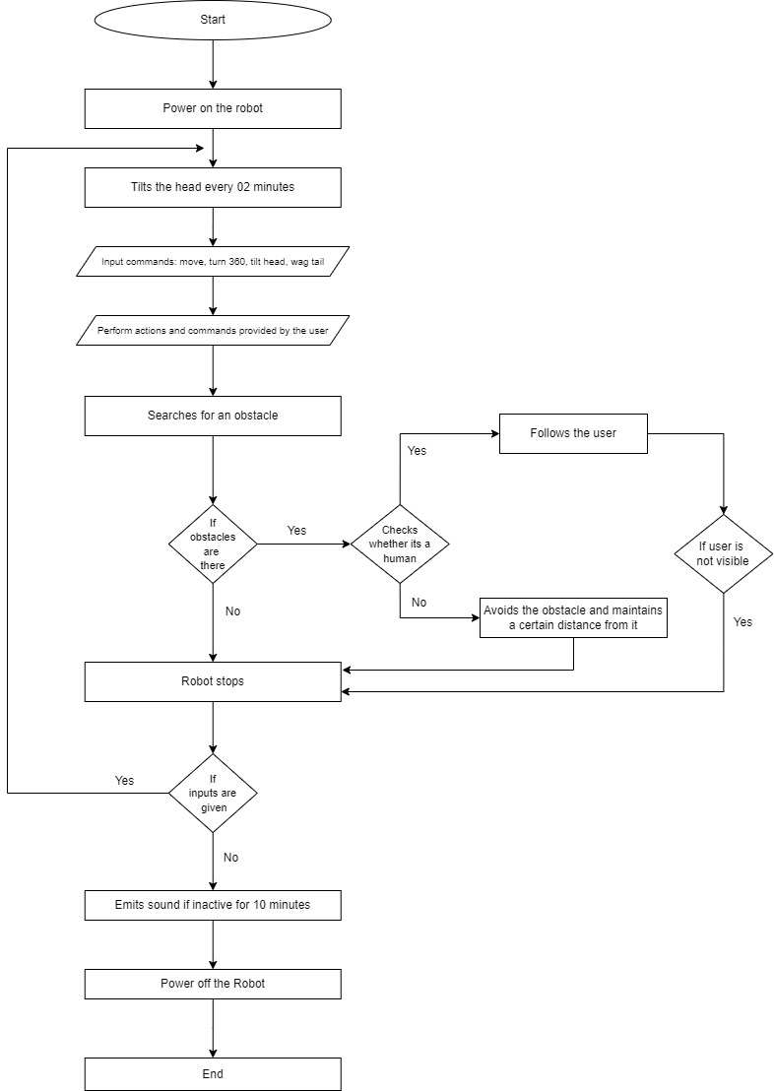

# Circuit Diagram (Simulation)

1. Move

1. Buzzer sound if user inactive for 10 minutes

1. LDR sensor on neck belt to light up automatically in dark times

1. Tilt the head twice every 02 minutes

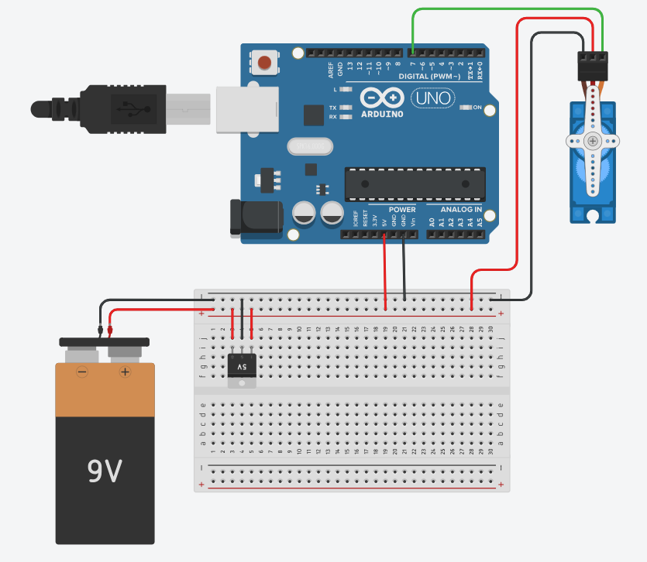

1. Wag tail

1. Avoid obstacles

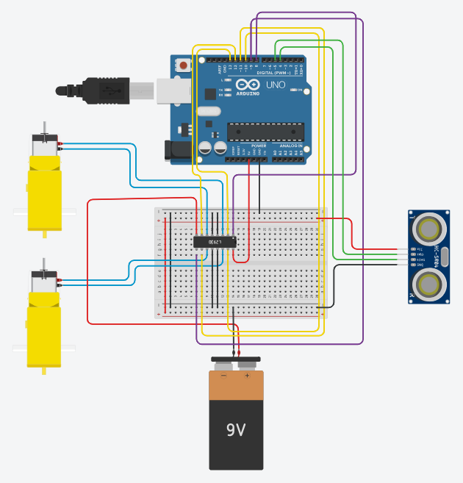

1. Follow the user

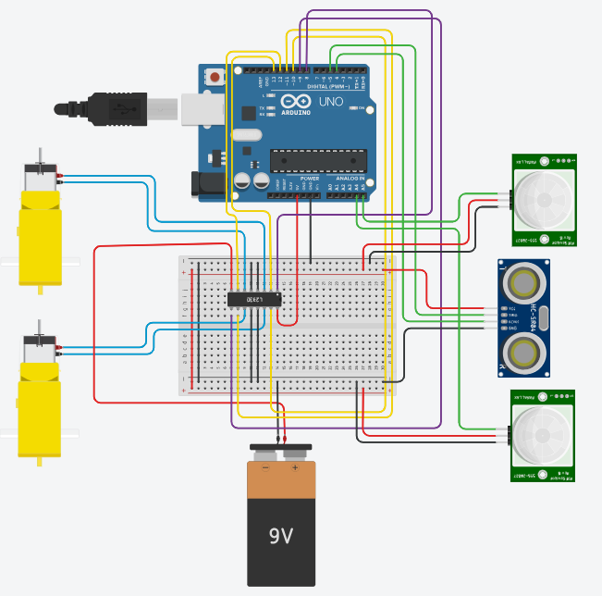

1. Overall Design

# Evaluating the robot

# 6.1 Results of the operation

Once the robot is implemented and ready to work, it will start to work according to user commands and by following the user.

The user can command by laptop to perform actions such as rotating, moving forwards and backward, tilting the head, wagging the tail and while the operation happens, if any obstacle is detected it will stop automatically while emitting a sound in certain times.

## 6.2 Limitation

As for the limitations of the project, the following can be considered.

* Some output and action errors may occur as the sensors may not work perfectly due to environmental changes.
* The robot will only trigger relevant user commands because it is designed to perform only certain tasks.
* Hardware may wear out with time and regular maintenance and fixes are required.
* The initial cost for implementing a robot is high.
* Battery life will be stored for a small time period, and it is needed to recharge.
* Limited storage of certain components cannot store large amounts of data.
* The robot cannot locomote across uneven surfaces smoothly.
* High and low temperatures will affect certain functionalities of components.
* Overtime usage may heat the system and cause failures.

## 6.3 Recommendation

As the future recommendations,

* Artificial intelligence can be applied to identify environmental changes and advance performance
* Can implement the robot to understand and identify selected users voice and emotions to provide more likely pet feeling using biometric sensors.
* Allow to respond to virtual assistants such as Alexa
* Implement data security measures.
* Enhance the design which is eco-friendly to prevent harm to environment.

In conclusion, the proposed project will act as a pet instead of a traditional pet in order to the need of owner for their ease of use.

# Timeline

|  |  |  |  |  |  |  |  |  |
| --- | --- | --- | --- | --- | --- | --- | --- | --- |
| Phases | Week  01 | Week  02 | Week  03 | Week  04 | Week  05 | Week  06 | Week  07 | Week  08 |
| Define the objectives |  |  |  |  |  |  |  |  |
| Research and Feasibility Study |  |  |  |  |  |  |  |  |
| Concept Design and Planning |  |  |  |  |  |  |  |  |
| Prototyping the Hardware |  |  |  |  |  |  |  |  |
| Coding the robot |  |  |  |  |  |  |  |  |
| Testing the functions |  |  |  |  |  |  |  |  |
| Debugging the errors |  |  |  |  |  |  |  |  |

1. Define the objectives

Find out a problem statement by researching a problem in the society and create a solution through a robot.

1. Research and Feasibility Study

Research about the relevant hardware components to implement the robot.

1. Concept Design and Planning

Gathering all those hardware components and make the connection in between them.

1. Prototyping the Hardware

Creating an outer cover with relevant hardware components to depict the shape of a pet with additional hardware components and connections.

1. Coding the robot

Choosing a programming platform and program the robot according to needed functions.

1. Testing the functions

Run the robot and identify its errors and areas to improve.

1. Debugging the errors

Debug and modify the robot with relevant modifications.